Noticing Certainty Seeking Behaviours 1.0
The uncertainty distress model is a trans-diagnostic and trans-situational framework to understand how threat and uncertainty can lead to distress including, but not limited to, anxiety. The model is available:
Freeston, M. H., Tiplady, A., Mawn, L., Bottesi, G., & Thwaites, S. (2020). Towards a model of uncertainty distress in the context of Coronavirus (Covid-19). the Cognitive Behaviour Therapist.
Open access available from: http://dx.doi.org/10.1017/s1754470x2000029x
Below is a version of the model that can be used for conceptualizing uncertainty distress and planning treatment. The specific focus of this worksheet is to build awareness of behavioural responses to uncertainty their contribution to perceived threat, perceived uncertainty and intolerance of uncertainty.
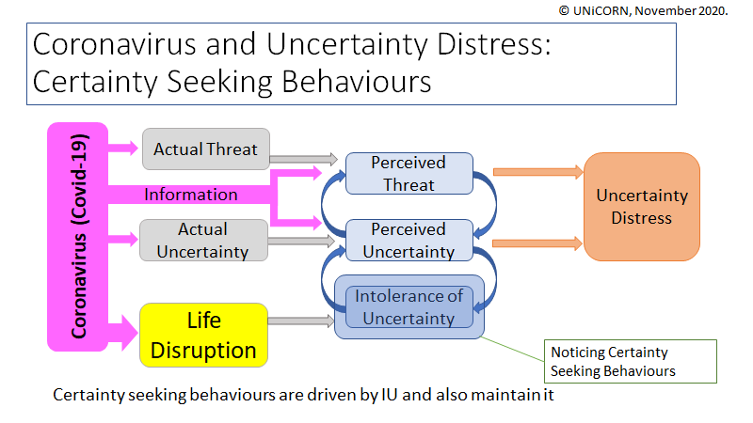
Making Friends with Uncertainty
This intervention is designed to bring awareness to the different ways in which uncertainty and certainty seeking behaviours can manifest in life. When people can identify certainty seeking behaviours, they may be able to consider ways of curbing their response. When people start to experience and sit with more uncertainty, they can start to build tolerance.
Sankar, R., Robinson, L., Honey, E., & Freeston, M. (2017). ‘We know intolerance of uncertainty is a transdiagnostic factor but we don’t know what it looks like in everyday life’: A systematic review of intolerance of uncertainty behaviours. In Clinical Psychology Forum. Newcastle University.
Bottesi, G., Carraro, E., Martignon, A., Cerea, S., & Ghisi, M. (2019). “I’m Uncertain: What Should I Do?”: an Investigation of Behavioral Responses to Everyday Life Uncertain Situations. International Journal of Cognitive Therapy, 12(1), 55-72.
These behaviours differ from the more familiar safety-seeking behaviours in classic CBT models of anxiety in the intended function of the behaviour. Safety seeking behaviours address the threat element (e.g. “I will die” in panic disorder) whereas certainty seeking behaviours are addressing the “unknown-ness” or uncertainty. They do not seek to make the threat outcome more or less likely, they just seek to reduce the uncertainty about it. Of course, in many situations people may be responding both to not knowing what will happen (including good or neutral outcomes) but also thinking about the negative outcome that might happen. In these situations, they may experience feelings associated with both uncertainty and threat.
Noticing Certainty Seeking Behaviours
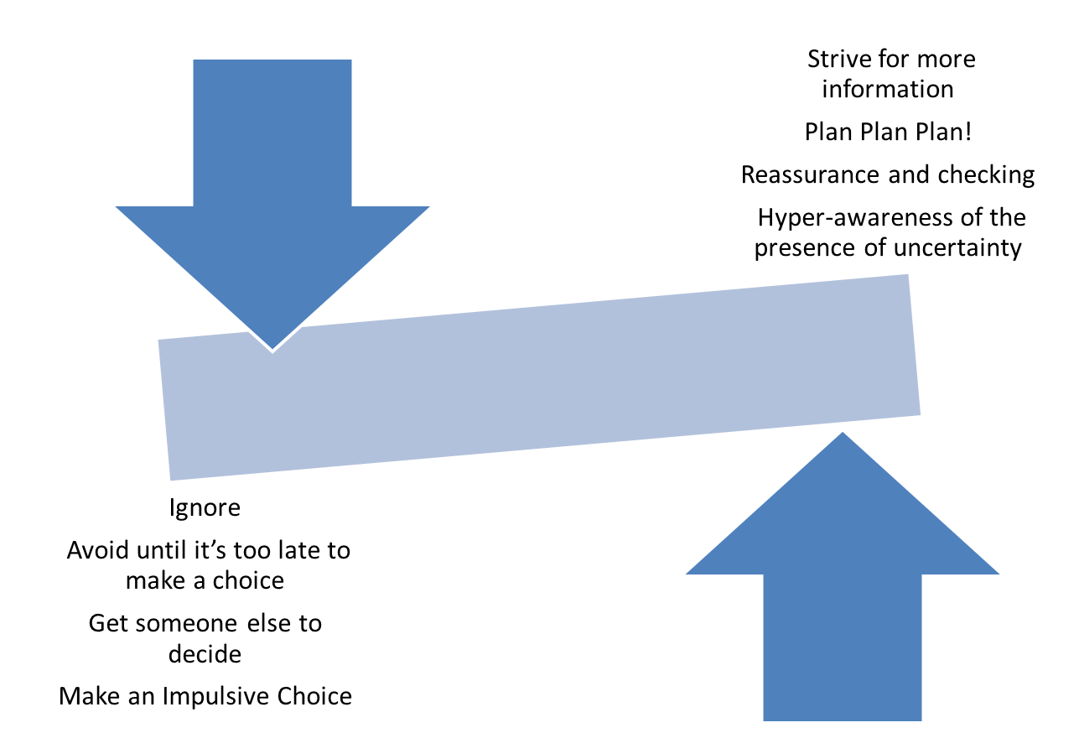
Over Engage
Flip Flop between the two
Under Engage

Therapist tips:
There are a wide range of certainty seeking or uncertainty reducing behaviours. In fact, almost any behaviour can be used for these purposes. It is the function of the behaviour rather than the form that is important. One discussion point could be, ‘what did you hope to achieve with this behaviour?’
The worksheet could be used to record experiences over a few days or to look in detail at one experience. When looking at the sensations, try to help people notice which sensations might be attributed to a stronger anxiety sensation as they think about the threat, and which might be related to the low level grumble of uncertainty when they think about “not knowing”. Remember the focus is what they are learning about uncertainty – not any specific threats that might come up.
Developing awareness of these behaviours is the first step to become better able to tolerate uncertainty. Ultimately, the aim is to help people neither to over-engage nor under-engage and simply sit with uncertainty.

Noticing Certainty Seeking Behaviours
Worksheet
The experience of uncertainty can be uncomfortable. Uncertainty is simply not knowing what is going to happen. And not knowing what will happen can apply to situations where the outcome could be positive, negative or neutral. In fact, some people find uncertainty about positive outcomes just as uncomfortable as uncertainty about negative outcomes. When people experience these uncomfortable feelings, they are likely to act in ways to try to make these feelings go away. These behaviours can be just about any behaviour that people use to try to make these feelings go away.
Sometimes when people get these uncomfortable feelings associated with not knowing what will happen, they get really involved in the situation and try and find out as much as they can, plan in great detail, check things, seek reassurance, or become really vigilant as they try and track was is happening. We call these behaviours over-engaging.
Sometimes people find that engaging with the situation is too uncomfortable, and so they try and ignore it, don’t do anything until too late, get someone else to decide, or just make a snap decision (even when they know it is not a good decision) just to make the feelings go away. We call these behaviours under-engaging. Sometimes people “flip-flop” between the two.
The worksheet below can help you notice the behaviours that you may use when you get these uncomfortable feelings. Remember, these behaviours can be just about anything that you do to try and make these uncomfortable feelings go away. Becoming more aware of these behaviours is the first step in being able to manage uncertainty differently.

Worked Example 1
Noticing Certainty Seeking Behaviours: Paul is a white man in his 30s living in the North East of England. He works for a local government agency as an analyst. He lives with his wife and two young children. Paul would have previously described himself as ‘a worrier’. During the pandemic he has started working from home full time and at times has had to balance this with childcare. He has not had Covid-19 but worries about the health impact for extended family who live in other parts of the country.
Name an Uncertainty  (Something that hasn’t happened yet)  Can you tune into it? | Sensation  What does this feel like?  Where do you feel it? | Notice Behaviours  How have you responded to this Uncertainty? | Is this Over Engaging Or Under Engaging? | What are the consequences?
Damp issues in house | Anxious  Sense that I should be doing something about it | Constantly looking for sources of damp  Thinking about possible sources  Dwelling on the consequences of the damp  Not actually doing anything about it – just dwelling | Over engaging in the worry  Under Engaging in the doing  Notice flip flopping between over and under engaging | Spend the whole time anxious and concerned and do not enjoy just living in the house  Consequences of inaction – damage to the house?  Not acting means I continue to worry
Child has a cough – is it Covid 19? | Anxious feeling in chest  Sensation of not knowing | Thinking through various scenarios and outcomes  Doubting decisions and whether correct actions taken, reviewing decisions already made | Over engaging | Unnecessary anxiety – there was nothing I could do about it
Planned paternity leave coming up | Uncertain  Subtle and hard to pinpoint physical sensation | When it comes into my mind I bat it away  Making some plans but not really thinking it through | Under Engaging in some ways  Sitting with the uncertainty in some ways | Not effectively planning for it when it does happen  Accepting I cannot make the decision right now

Worked Example 2
Noticing Certainty Seeking Behaviours: Ayesha is a woman in her 30s of South Asian background, although she was born and raised in the UK. She practices Islam and is a mental health worker. She lives with some extended family and has been impacted by the pandemic through personal disruption to living arrangements and professional disruption through work. She is also doing a university course. Some of her family members have had Covid-19 which has required treatment in hospital, and this has caused significant amounts of uncertainty distress and anxiety.
Name an Uncertainty  (Something that hasn’t happened yet)  Can you tune into it? | Sensation  What does this feel like?  Where do you feel it? | Notice Behaviours  How have you responded to this Uncertainty? | Is this Over Engaging Or Under Engaging? | What are the consequences?
What impact will Covid-19 have on University course?  Will I be able to meet deadlines?  Will I have enough data to do my assignments? | Panicky  heart racing and tight feeling in chest  Breathing feels shallow  Constant sensation of heaviness in upper stomach and lower chest | Worrying that Uni will think I am not committed or not good enough, predicting what others will think of me  Trying to think and plan ahead, being organised.  Reading course handbook frequently: checking deadlines  Reassuring myself that I am not forgetting anything  Frequently checking the news  Cut off from work  Procrastinate  Praying: handing over to God when it feels too much  Trying to take one day at a time. Remind myself that I have tolerated similar situations before: I will figure this out | Over engaging  Over engaging  Notice flip flopping between over and under engaging  Under engaging  Sitting with Uncertainty | I feel pressured to do more feeds into uncertainty  Creates a feedback loop  Physically exhausted  I feel overwhelmed and not in control: more work is coming my way. I feel blocked and that things are not moving.  Feel more in control  Some belief that I will get through this  Function better

Noticing Certainty Seeking Behaviours

Name an Uncertainty  (Something that hasn’t happened yet)  Can you tune into it? | Sensation  What does this feel like?  Where do you feel it? | Notice Behaviours  How have you responded to this Uncertainty? | Is this Over Engaging Or Under Engaging? | What are the consequences?

